

SIMATS ENGINEERING

Saveetha Institute of Medical and Technical Sciences Chennai- 602105
Student Name: ASHOK KUMAR S Reg. No.:192424376
Course Code: DSA0423 Slot: D
Course Name: DSA0423 - Fundamentals of Data Science for NLP
Course Faculty: Dr. Senthilvadivu.S

Project Title:Design and Evaluation of Bayesian-Based Portfolio Optimization Models Using Financial Market Data

Module Photographs:
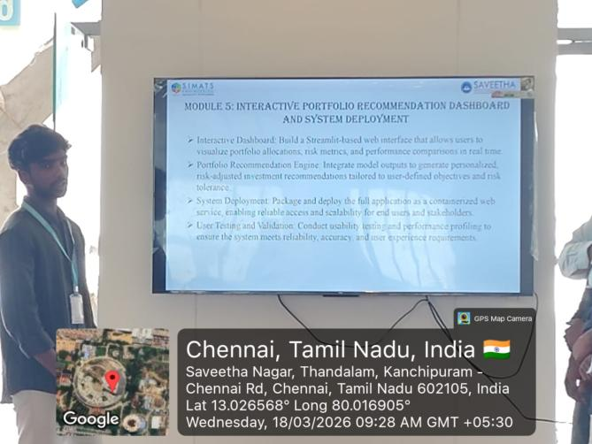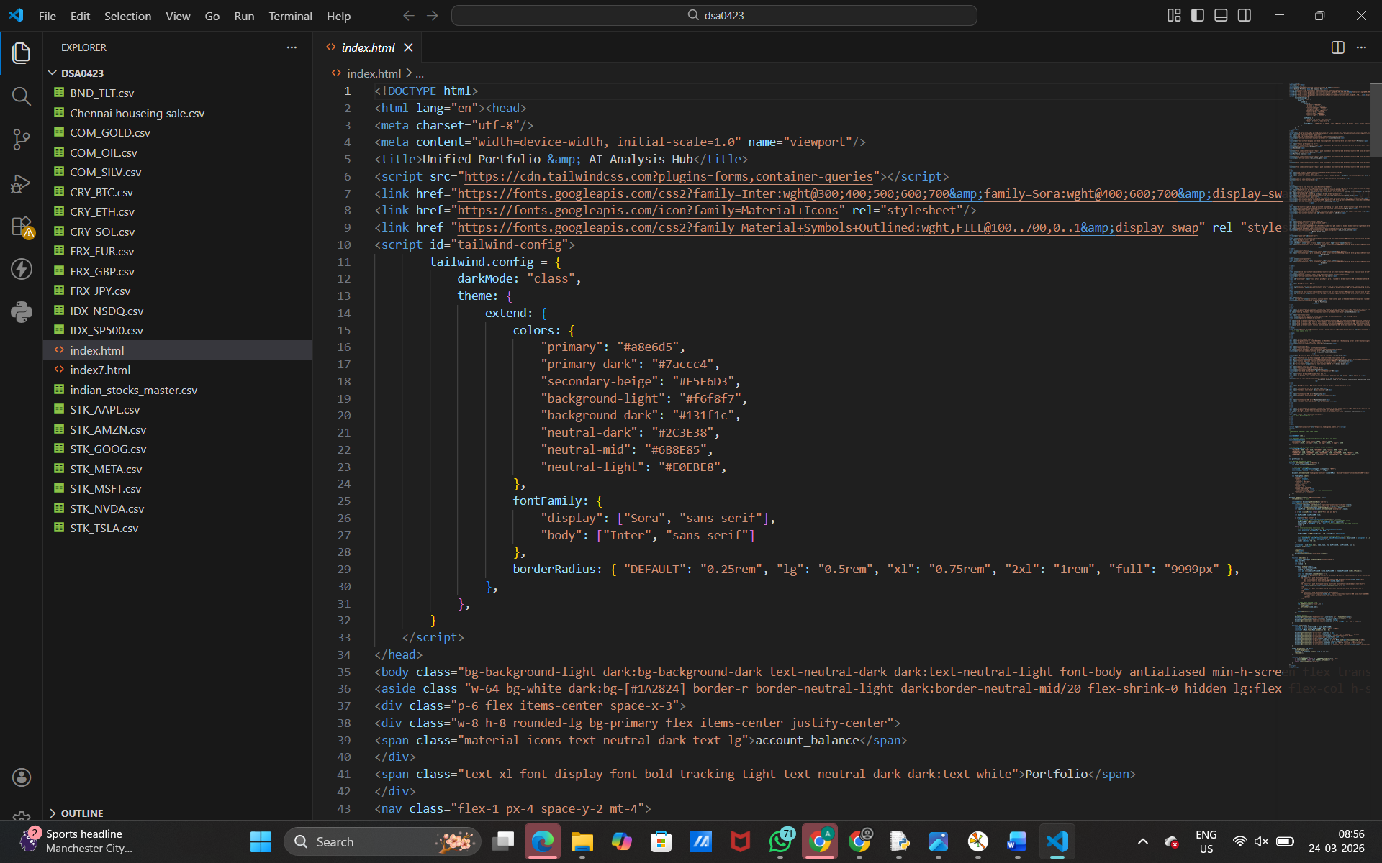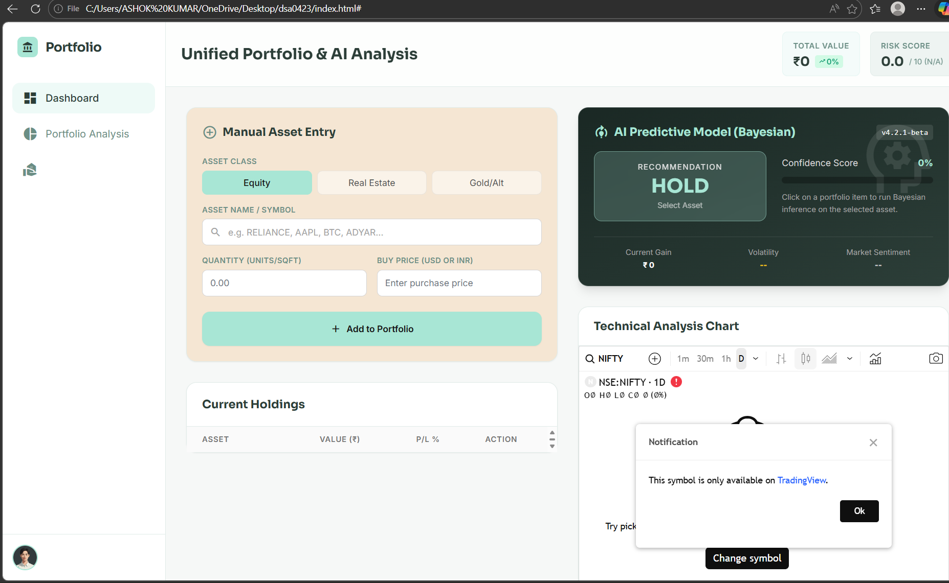
Project Description:
In Module 5, our primary contribution was to evaluate the effectiveness of different Bayesian inference models and compare their performance in terms of return optimization and risk mitigation. After implementing the portfolio selection models in the previous modules, we focused on testing, validating, and bench marking their results under various market conditions.To measure performance, we used standard financial evaluation metrics such as average portfolio return, portfolio variance, standard deviation, and risk-adjusted performance indicators like the Sharpe Ratio. These metrics helped us assess whether the Bayesian models were generating higher returns while maintaining controlled levels of risk. We also analyzed maximum draw down and volatility to understand how each model behaved during market downturns and uncertain periods.We conducted a comparative analysis between multiple approaches, including Bayesian Mean-Variance Optimization, Bayesian Linear Regression-based prediction, and traditional Mean-Variance Optimization methods. The comparison was based on predictive accuracy, stability of portfolio weights, responsiveness to new market data, and overall risk-return trade off. By applying backtesting techniques on historical datasets, we simulated real-world investment scenarios to observe how each model would have performed over time.

Student Signature Guide Signature

